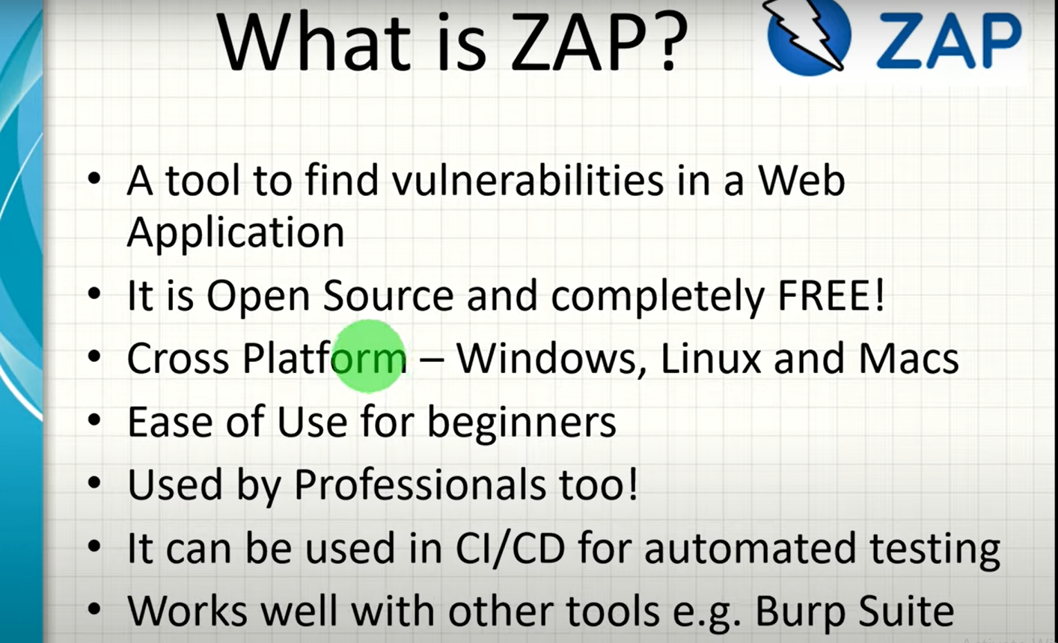

**Main Features of ZAP:**

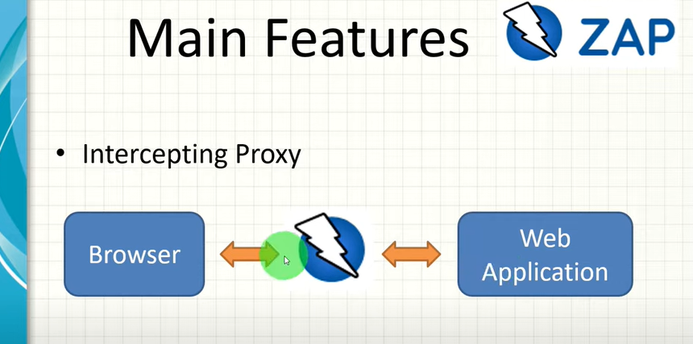

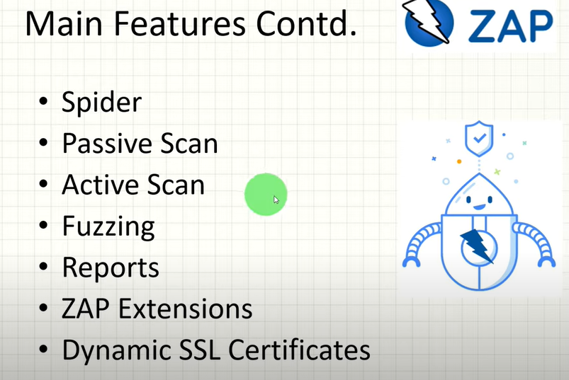

**ZAP Dynamic SSL Certificates:**

Secure Socket Layer:

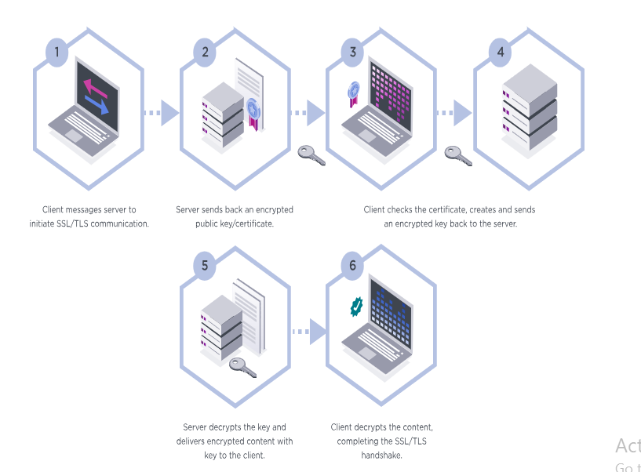

**Proxy Web Traffic Through OWASP ZAP:**

**Configuring FoxyProxy.**

**Intercepting Requests with OWASP:**

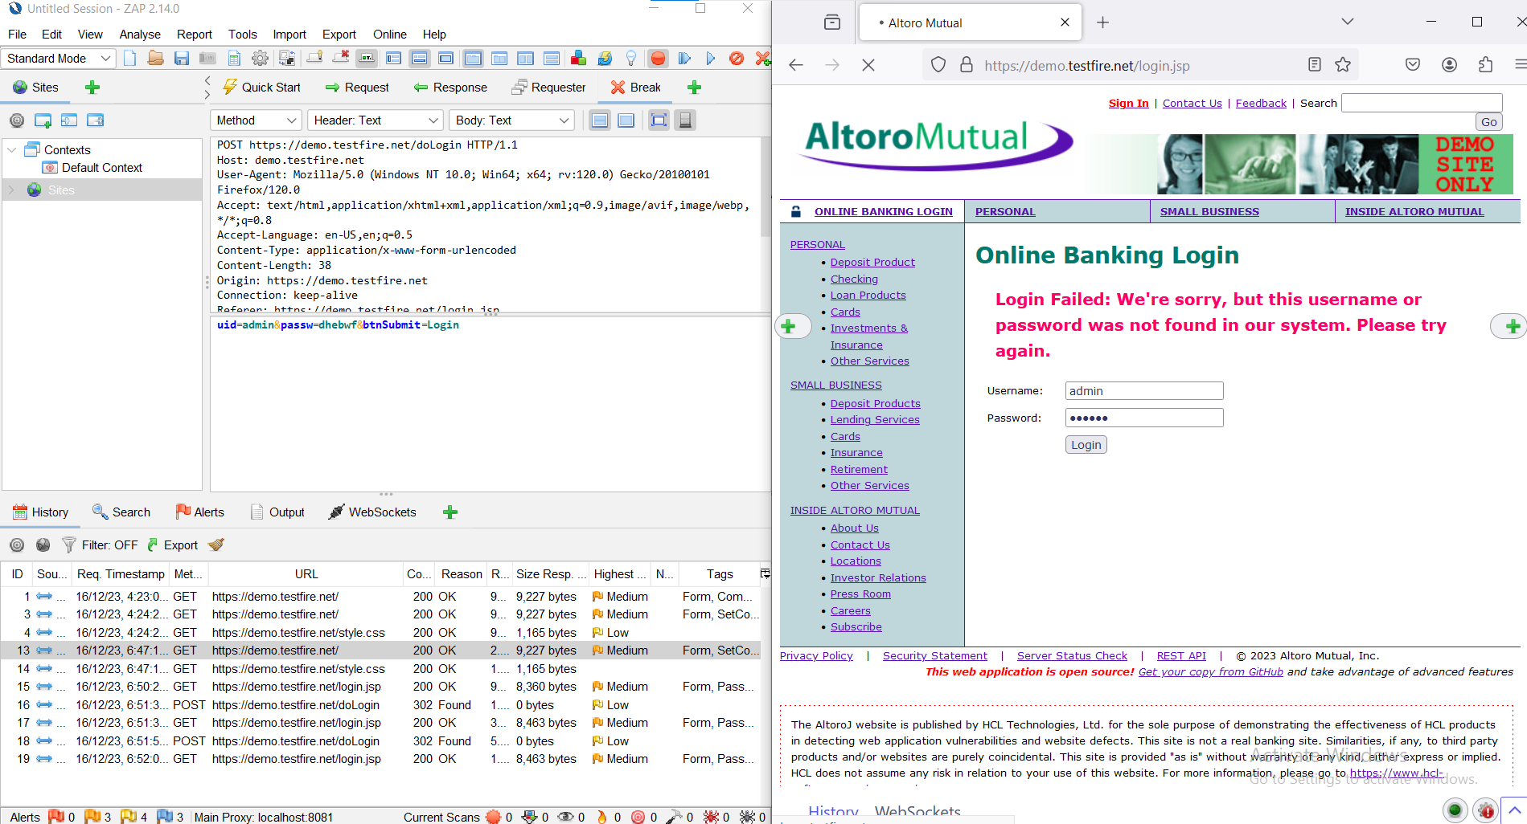

**Manual Exploring Vulnerability in OWASP:**

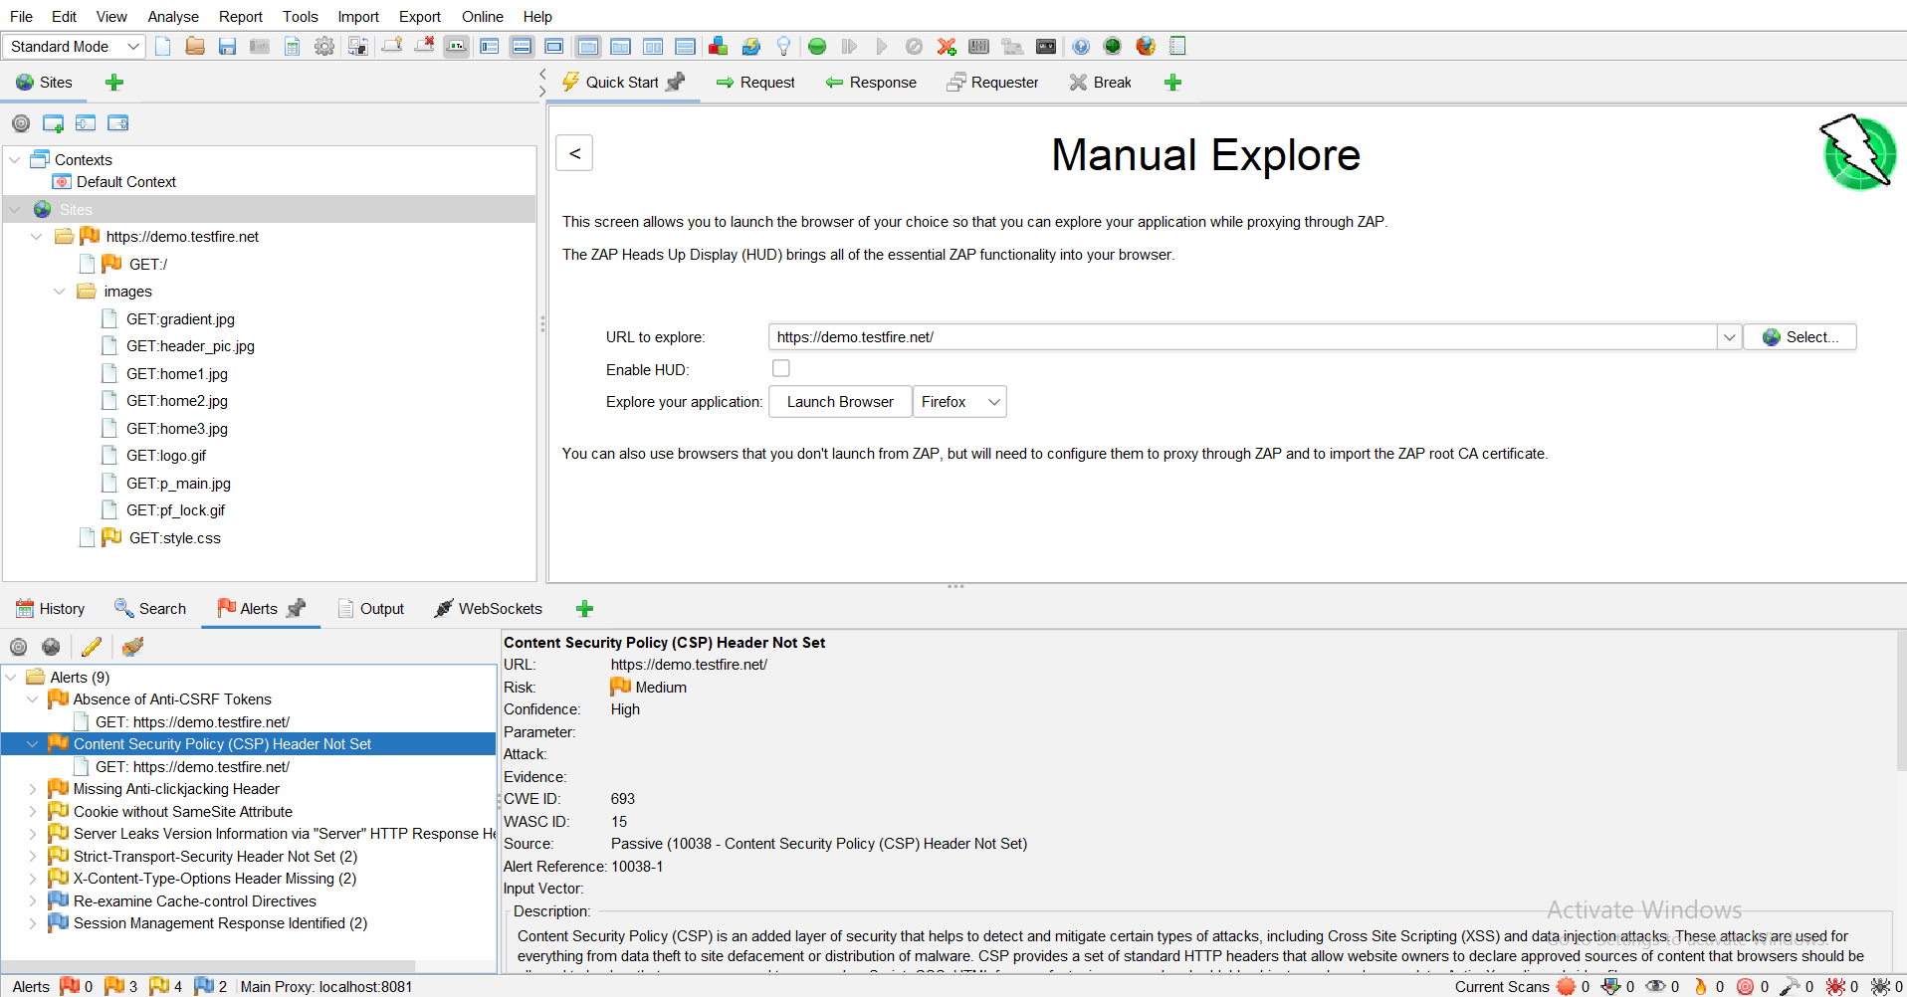

**Spidering a Website with OWASP ZAP:**

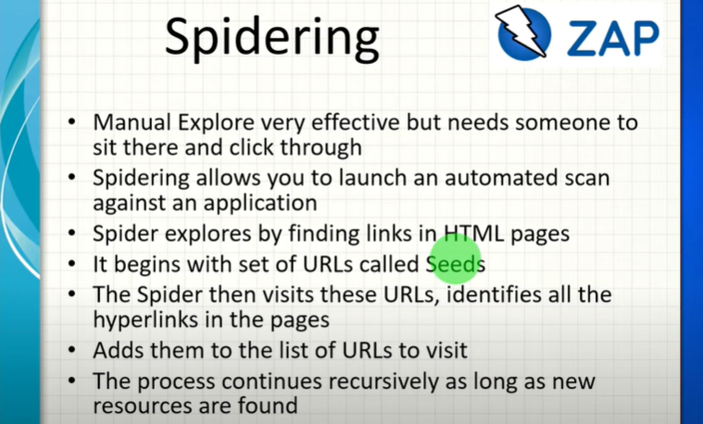

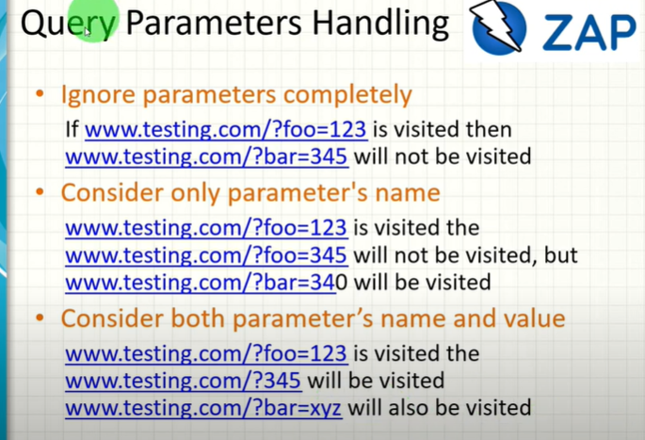

**Automated Vulnerability Assessment of a Single Page/Partial site/ Entire Site:**

**Generating Vulnerability Assessment Reports in ZAP:**

**Contexts, Scope and Modes in ZAP:**

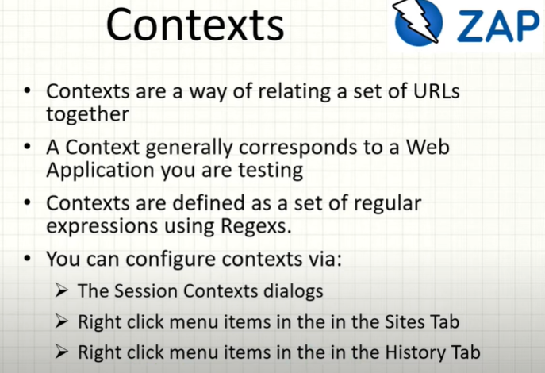

**Sessions in the ZAP:**

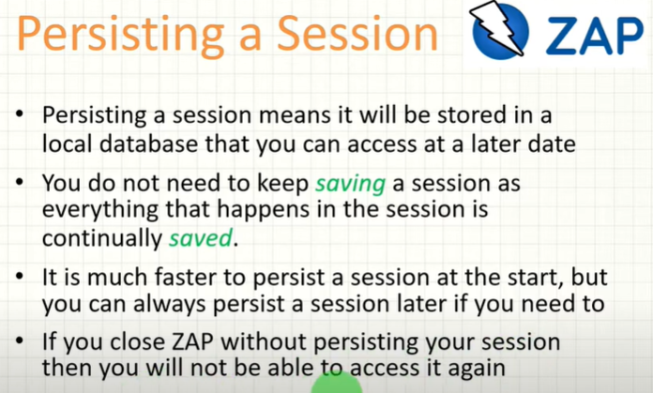

**ZAP Request Editor:**

**What is Passive Scanning:**

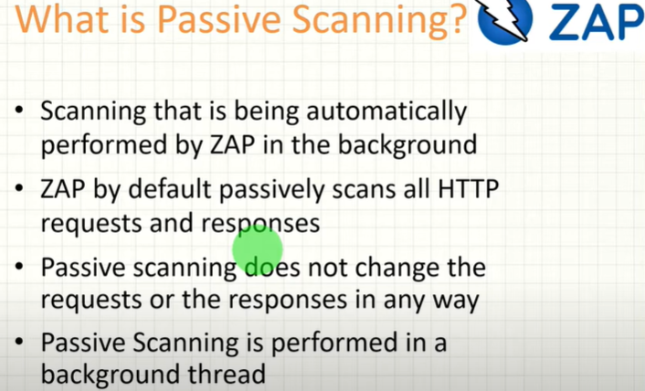

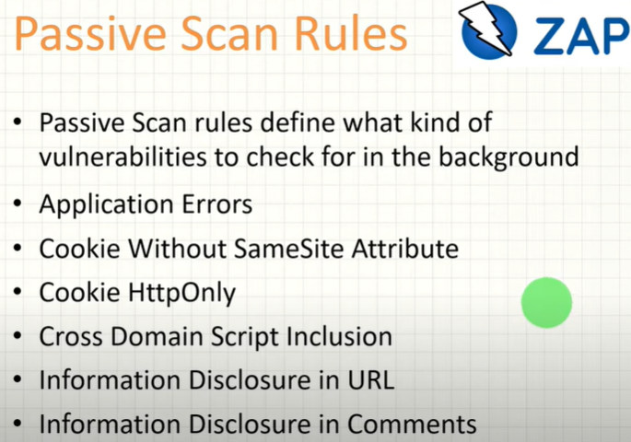

**Active Scanning:**

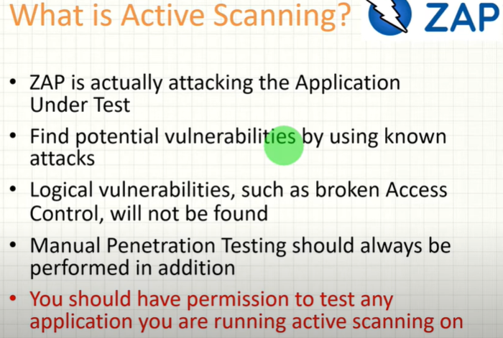

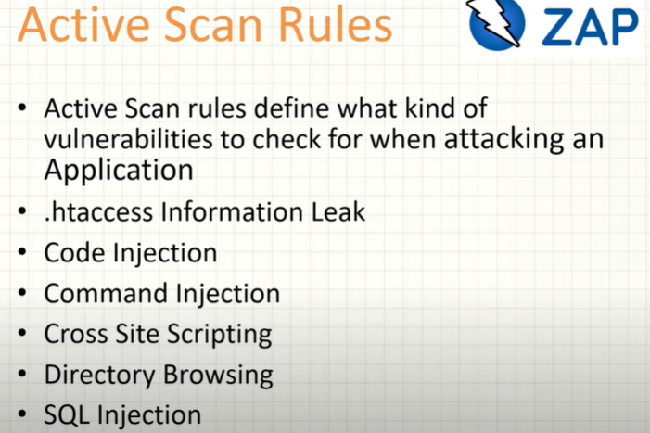

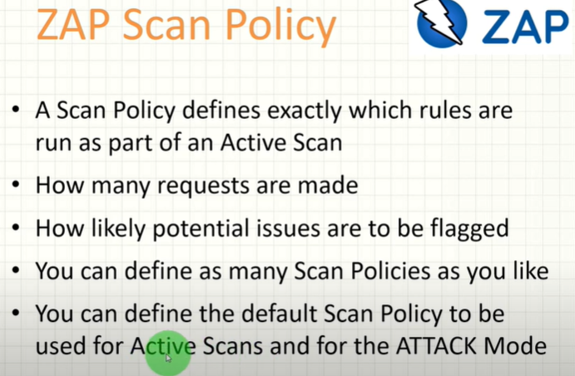

**CSRF Tokens:**

**Content Security Policy (CSF): Headers**